**Work-done in lab Session**

1. **”Startup Name Generator” App**

a simple app that generates proposed names for a startup company. The user can select and unselect names, saving the best ones. The code lazily generates 10 names at a time. As the user scrolls, more names are generated. There is no limit to how far a user can scroll. This app will contains the stateful List view which contains the names as an items.

* **main.dart** file

|  |
| --- |
| import 'package:flutter/material.dart';  import 'package:english_words/english_words.dart';  void main() => runApp(MyApp());  class MyApp extends StatelessWidget {  @override  Widget build(BuildContext context) {  return MaterialApp(  title: 'Startup Name Generator',  home: RandomWords(),  );  }  }  class _RandomWordsState extends State<RandomWords> {  final _suggestions=<WordPair>[];  final _biggerFont =const TextStyle(fontSize:18.0);  Widget _buildSuggestions(){  return ListView.builder(  padding: const EdgeInsets.all(16.0),  itemBuilder: (context,i){  if(i.isOdd) return Divider();  final index=i ~/ 2;  if(index>=_suggestions.length){  _suggestions.addAll(generateWordPairs().take(10));  }  return _buildRow(_suggestions[index]);  }  );  }  Widget _buildRow(WordPair pair){  return ListTile(  title: Text(  pair.asPascalCase,  style: _biggerFont,  ),  );  }  @override  Widget build(BuildContext context) {    return Scaffold(  appBar:AppBar(  title:Text('Startup Name Generator'),  ),  body:_buildSuggestions(),  );  }  }  class RandomWords extends StatefulWidget {  @override  _RandomWordsState createState() => _RandomWordsState();  } |

**Output:**

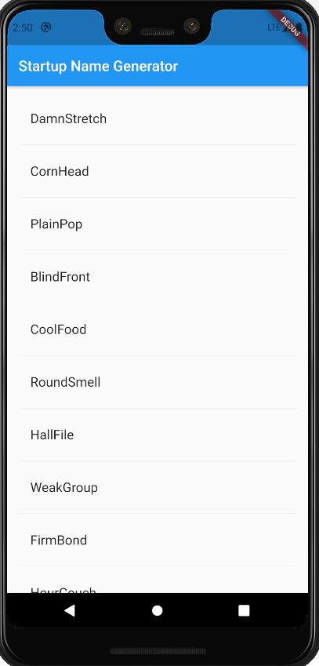

Check the below link for video.

<https://drive.google.com/file/d/1u34wtseqQvwY2rKWXqOa8z-FLbe-AcIz/view?usp=sharing>